REQUEST FOR PROPOSAL

Renovation/ Construction 2024

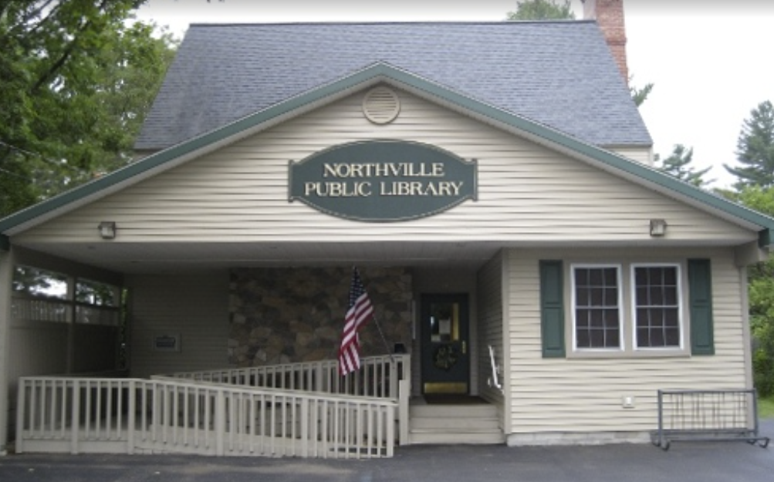

Northville Public Library (NPL)
January 2024

Table of Contents
Contents
PART A: GENERAL INFORMATION 2
1.0 INTRODUCTION 3
2.0 SCOPE OF WORK 3
3.0 MATERIAL SPECIFICATIONS 4
4.0 ATTACHMENTS 5
5.0 QUESTIONS & CLARIFICATIONS 5
6.0 SELECTION PROCESS 6
7.0 METHOD & DUE DATE OF SUBMITTAL 6
8.0 KEY DATES SCHEDULE 7
PART B: PROJECT INFORMATION 7
1.0 GOALS & OBJECTIVES 7
2.0 SCOPE OF SERVICES 7
3.0 BUDGET 8
PART C: SUBMITTAL REQUIREMENTS 8
1.0 COVER LETTER 8
2.0 GENERAL INFORMATION 8
3.0 TEAM ORGANIZATION & LIST OF KEY PERSONNEL 8
4.0 EXPERIENCE 8
5.0 EXAMPLES OF RELEVANT PROJECTS 9
6.0 BONDING 9
7.0 FINANCIAL 9
8.0 PROJECT SCHEDULE 10
9.0 SCOPE OF WORK 10
10.0 SUBMISSION CONTENT REQUIREMENTS 10
PART D: ONSITE VISITS 10
1.0 ATTENDEES 11

PART A: GENERAL INFORMATION

INTRODUCTION
This document provides information about the initiative and requirements for your written submission/response. Also included is information and requirements for a potential oral presentation, or interview, with Board of Trustees.

SCOPE OF WORK
NPL has initiated a capital redevelopment program, the outline is as follows:
Building Location: 341 S 3rd St, Northville, NY 12134
Overview of individual items
- Replacement of four back windows and corresponding jams
  - outdoor stone siding replacement
- Bathroom ceiling leak-repair/replace boot on the roof
- Roof remediation
- Repair Cracks in interior walls second floor
- Emergency Exit (back door) closure problem.
- Front door-upgrade
- Motion sensor light switch in restroom

Specifics on above listed items
Replacement of four back windows and corresponding jams
    - Removal of existing windows and wood jams
    - Installation of triple pane windows and jams similar size.
    - Remediation of exterior and installation of drip edge above windows

Replace bathroom vent boot
- Repair and paint bathroom ceiling

Roof remediation-metal roof
- Remove loose paint.
- Remediate rust spots.
- Paint entire roof.

Repair Cracks in interior walls second floor
    - Repair cracks in corners (two areas).
    - Paint repaired areas.

Emergency Exit (back door) closure problem
    - Evaluate underlining cause(s).
    - Repair, if possible, if not repairable replace

Front door-upgrade
    - Install handicap electronic opener.
    - Install an entry alert (audible)

Motion sensor light switch in restroom
    - Remove the current toggle light switch.
    - Install a motion detector in the bathroom interior to control lights and fan.

MATERIAL SPECIFICATIONS

- Windows
  - The interior of the library must be protected from the elements and construction hazards at all times.
  - The size of replacement windows must be as close as possible to the current size. Current size 58x94”
  - Must be triple pane with low-E glass.
  - Jams to be constructed of pine then stained (to match existing) and polyurethane.
  - The exterior drip edge installed above the windows shall constructed from aluminum coil stock with a color to match the roof.
- Roof
  - All loose paint must be removed.
  - Any areas showing rust must be remediated.
  - The roof paint must be appropriate and approved for metal roofs.

- Sheetrock repair
  - Corner bead shall be used where appropriate.
  - Multiple coats of spackle should be applied and sanded.
  - Two coats of paint applied to remediated areas.

- Exterior doors
  - Must meet NYS standards for handicap accessibility.
  - Must be equipped with a “Panic Bar”.
  - Electronic opener (front door only) must meet NYS standards for handicap accessibility.
  - Audible entry alarm must be at least 80db, ideally volume is adjustable.

- Wiring
  - Motion sensor light switch must have a 90sec or greater on cycle
  - MC cables for concealed branch circuits as permitted by code.
  - EMT Conduit and building wire for exposed branch circuits.
  - EMT Conduit and building wire for feeders to panelboards.
  - Flexible cables to motors.
  - All exterior exposed wiring when run above grade shall be run in galvanized rigid steel conduit utilizing compression fittings.
  - Utilize set screw fittings where inaccessible to the public and compression fittings where accessible to the public.
  - Steel junction, pull and work boxes for splicing, pulling and devices.
  - Cast boxes with required conduit entry points in areas surfaced mounted and accessible to the public.
  - Utilize expansion fittings for exterior exposed application and interior when \

ATTACHMENTS
The following photographs are provided as supplemental materials for use in preparing your submittal located on

For general information about the Library and their services, please visit https://northvillepubliclibrary.mvls.info/
Please note that these materials are provided as background information only.

QUESTIONS & CLARIFICATIONS
Any questions or requests for additional information regarding the project, selection process, or the attachments are to be made only in writing and transmitted electronically to:

Richard Cole, email: richardwcole6774@gmail.com

All questions must be received by the date specified in the Key Dates section of this document. Responses to all questions/inquiries received will be distributed to all participating firms before the submittal due date.

SELECTION PROCESS
The materials submitted by interested firms will be reviewed by an evaluation committee comprised of members of NPL’s Board of Trustees. The Committee will employ a qualifications-based selection process incorporating the following criteria in its evaluation:

- Relevant project experience.
- Experience, skill set, and demonstrated leadership of the proposed project team.
- Ability to comply with the proposed project schedule.
- Financial capability.
- Construction experience.
- Experience working with not-for-profit organizations.
- Familiarity with project site/location.
- Experience with similar project types and programs.
- Interaction with owner and consultant throughout the selection process.

NPL reserves the right to reject any and all qualifications and subsequent proposals, including those that do not provide the requested information.

METHOD & DUE DATE OF SUBMITTAL
Regardless of delivery method, submission materials must be delivered and received by the individuals below NO LATER THAN as indicated in the Key Dates section. Packages and email messages must be marked as indicated below. Electronic delivery of materials is preferred.

ELECTRONIC DELIVERY – EMAIL

Electronic delivery of submission materials is required. For submittals delivered by email, please address email to the following recipients:

- northvillepubliclibrary@gmail.com

The subject line for all electronic submittals should be as follows:

Renovation/ Construction

HARD COPY DELIVERY
Hard copy submissions are also required. For hard copy submissions, Four (4) copies of all materials must be delivered in a SEALED package, to:

The Northville Public Library
341 South Third St
Northville, NY 12134

During normal library hours or drop into book drop box after hours

The outside of the sealed package shall be marked with the following identification:
Renovation/ Construction

8.0 KEY DATES SCHEDULE
KEY DATES
RFP Issued | February 28, 2024
Site Tour | Normal Library Operating Hours
Written Questions Due | March 29, 2024
Submissions Materials Due | April 29, 2024
Preliminary Screenings | May 2, 2024
Virtual Interviews | May 16, 2024

It is recommended that participating firms prepare their whole project team for a tentative interview by holding the scheduled interview date should an interview be extended.

PART B: PROJECT INFORMATION

1.0 GOALS & OBJECTIVES

It is expected that once selected, the successful firm will immediately begin delivery of pre-construction services, including project cost estimating and value assessment. Following the successful awarding of the various sub-contracts, the successful firm will be expected to manage the general construction effort for the project(s). Throughout the process, the selected firm will also be expected to perform services related to project schedule development and maintenance.

2.0 SCOPE OF SERVICES
The Scope of Work shall be as indicated in the earlier and as outlined above. The Scope of the Work will involve and construction phase services, with the intended form of contract for the project being AIA Document A133-2009 (GMP), with AIA Document A201– 2007, General Conditions of the Contract for Construction. The Scope of the Work shall include all necessary site work required for occupancy.

Any objections to such a basis for the form of agreement should be articulated in the submission made in response to the Request for Proposals (RFP).

3.0 BUDGET
The total cost for construction for the projects, including site development work, is currently included in the Scope of the Initiative Section of this document and does not include costs associated with furnishings, fixtures and equipment, architectural and related professional services fees, Owner-controlled contingencies, and fundraising costs.

PART C: SUBMITTAL REQUIREMENTS

The submittal must include the following information in sections as numbered below.

COVER LETTER
A cover letter, signed by an officer of the firm, containing a commitment to provide the services required if selected, with the proposed personnel, while also expressing interest in the project.

GENERAL INFORMATION
The following information should be included in the submission:
- Name and address of firm
- Contact Person
- Date firm was established and last change, if any, in ownership or senior management
- Firm history

TEAM ORGANIZATION & LIST OF KEY PERSONNEL
Provide an organizational chart identifying all team members, relationships and responsibilities throughout the various phases of the project including initial design, cost estimating, and on-site construction management and administration.

Public libraries, as described in Section 253(2) of NYS Education Law, are subject to the prevailing wage law.

EXPERIENCE
As a non-profit organization, NPL must establish a scope for each project that is both reasonable and within its project funding budget. The selected firm will be expected to function as a member of the team with the Owner (NPL), and any sub-contractors helping to determine and maintain a scope of work and cost, within established parameters, for the project. To that end, please share/include:

- The firm’s experience working in such a capacity.
- The contributions the firm will make throughout the process to ensure the success of the initiative.
- Identify all proposed consultants/subcontractors including the firm name, address, phone and primary contact.

EXAMPLES OF RELEVANT PROJECTS
Provide information on relevant experience with comparable projects completed in the last six years or currently in progress, in the format which follows:

(Please limit to three examples)

Project Information
Project Name
Project Location Project Type
Project Scope in Square Feet and Construction Cost
Firm’s Project Management Firm’s Project Superintendent Name of Architect of Record
Client Information
Client Name
Client Contact Name, Title, Address, Telephone Number
Completion Information
Date of Completion; Length of Project
Contract Information
Original Construction Budget
Original Construction Contract Amount Final Construction Contract Amount Original Completion Schedule
Actual Completion Schedule Contract Type

BONDING
Provide evidence of the firm’s bonding capacity, rate and maximum liability coverage. Please identify any past or current claims of litigation with which the firm has been or is presently involved.

FINANCIAL
Attach a letter from your bank/financial institution stating the following:
  - length of time the firm has been doing business with said bank/institution,
  - extent of credit available and terms of availability
  - Builder’s Risk Insurance
  - Bonding Fees
  - Taxes
  - Permit Fees

PROJECT SCHEDULE
The timely completion of services is important to the overall success of the initiative. Provide a proposed timeline/schedule depicting the anticipated activity of the firm during the various phases of the project. The proposed schedule will be evaluated upon the amount of time your firm estimates is required to execute the scope of services while maintaining the necessary levels of quality control to meet professional standards.

SCOPE OF WORK
The Scope of Work shall be as indicated in the earlier and as outlined above. The Scope of the Work will involve both pre-construction and construction phase services, with the intended form of contract for the project being AIA Document A133-2009 (GMP), with AIA Document A201– 2007, General Conditions of the Contract for Construction. The Scope of the Work shall include all necessary site work required by the owner for occupancy.

SUBMISSION CONTENT REQUIREMENTS
Present fee proposal as follows:

Prior is required for all building material that costs exceeds $500 for this project. Include an outline of the work to be performed and proposed fees associated with the firm’s delivery of said pre-construction services during the design development and construction documentation phase of the project, including, but not limited to cost estimating, drawing/constructability review, scheduling.

- General Conditions: Reported as a fixed fee, per month
- Overhead and Profit: Reported as a percentage of the Cost of the Work
With the understanding that the scope of the project, and anticipated construction costs are as indicated above and as described in earlier, please include in this fee all work or services to be performed in managing the construction during the construction phase of the project with the exception of those items reported in items (B) and (D).

- Reimbursable Expenses: Reported as a not-to-exceed amount
Include all anticipated additional expenses associated with the performance of construction management for the project and not included in item (B) above. A description of the items included in this category should be included.

PART D: ONSITE VISITS

1.0 ATTENDEES
The key individuals responsible for both construction and pre-construction services for the project should plan on visiting the site. A list of attendees will be requested when the presentation time is scheduled.

Individual solicitation of these library staff or NPL board members throughout the selection process is prohibited.

